ANALYZING HOUSING PRICES IN METROPOLITAN AREAS OF INDIA

PROJECT REPORT

1. INTRODUCTION
1.1 Overview
1.2 Purpose

2. Problem Definition & Design Thinking
2.1 Empathy Map
2.2 Ideation & Brainstorming Map

3. RESULT
3.1 Data Model
3.2 Activity & Screenshot

4. ADVANTAGES & DISADVANTAGES

5. APPLICATIONS

6. CONCLUSION

7. FUTURE SCOPE

ANALYZING HOUSING PRICES IN METROPOLITAN AREAS OF INDIA

1. INTRODUCTION

1.1 Overview
- House price prediction can help the developer determine the selling price of a house and can help the customer to arrange the right time to purchase a house. There are three factors that influence the price of a house which include physical conditions, concept and location.
- House price prediction in a metropolitan city in India is a valuable solution for potential home buyers, real estate agents, and investors. By leveraging historical sales data, property details, and location-specific information, a predictive model can accurately estimate house prices.

2.1 Purpose

- The House Price Prediction is one of many economic indicators that investors use to keep a pulse on broader economic trends and potential shifts in the stock market. The rise and fall of house prices can have big implications for the economy.
- Metro cities in India are home to a large population and attract a large number of people from other regions seeking job opportunities, education, and better quality of life. The high demand for housing in these cities leads to a rise in property prices.
- Prediction house prices are expected to help people who plan to buy a house so they can know the price range in the future, than they can plan their finance well.

2. Problem Definition & Design Thinking
2.1 Empathy Map
Use this framework to develop a deep, shared understanding and empathy for other people. An empathy map helps describe the aspects of a user’s experience, needs and pain points, to quickly understand your user’s experience and mindset.

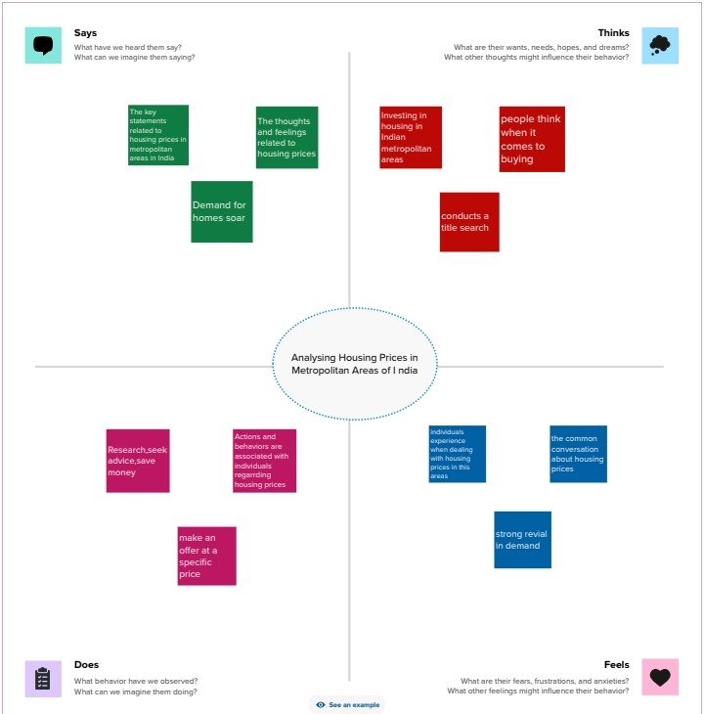

2.2 Ideation & Brainstorming Map

3. RESULT

3.1 Data Model
- Specify the business problem
- Business requirements
- Literature Survey
- Social or Business impact
3.2 Activity and screenshot
Milestone 1: Define problem/ Problem Understanding
Activity 1: Specify the business problem
How to analyze the Housing prices in Metropolitan Areas of India
Activity 2: Business Requirements
The solution should have a user-friendly interface, ensure transparency and explain the ability of predictions, prioritize data privacy and security, and define performance metrics for evaluation.
Activity 3: Literature Survey
Hedonic prices and implicit Markets: Product Differentiation in pure competition. Specification and estimation of hedonic housing price models. Understanding house price appreciation using multi-source big geo-data and machine learning
Activity 4: Social or Business impact
Social Impact: Houses with best facilities in India. By analyzing the number of bed rooms and services provided.
Business Model/ Impact: Can make this visualization application available for people, for more insights and ideas.
Milestone 2: Data Collection & Extraction
Dataset can be collected from different sources. Data collection is the process of gathering and measuring information on variables of interest, in an established systematic fashion that enables one to answer stated research questions, test hypothesis, evaluate outcomes and generate insights from the data.
Activity 1: Downloading the dataset
Download the dataset using the link given below
https://drive.google.com/drive/folders/1pm04WDkkRqK7MefHeybYYszi32puOj7u?usp=sharing

Activity 1.1: Understand the data
Data contains all the Meta information regarding the columns described in the CSV files. We have provided a CSV file.

Activity 2: Connect Dataset with Tableau
Open a Tableau and Add the dataset file in the text option and the dataset will be connected.
Milestone 3: Data Preparation

Activity 1: Prepare the Data for Visualization
Here the dataset is available and the visualization are showed in the activity

Milestone 4: Data Visualization
To create a graphical representation of data, by using visual elements such as charts, graphs, and maps, data visualization. To identify patterns, trends, and outliers in the data

Activity 1: Number of Unique Visualizations
It can be created by using a given dataset. It can be include bar charts, line charts, heat maps, scatters plots, pie charts, Maps etc.
Activity 1.1: Latitude and Longitude based on Location

- Drag Longitude generated in columns
- Drag latitude generated in rows

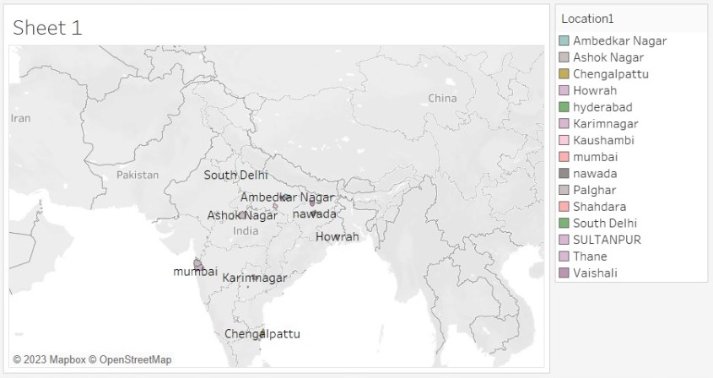

Activity 1.2: Number of houses based on area in Square feet

- Drag the SUM (Price) in columns
- Drag the Area in rows

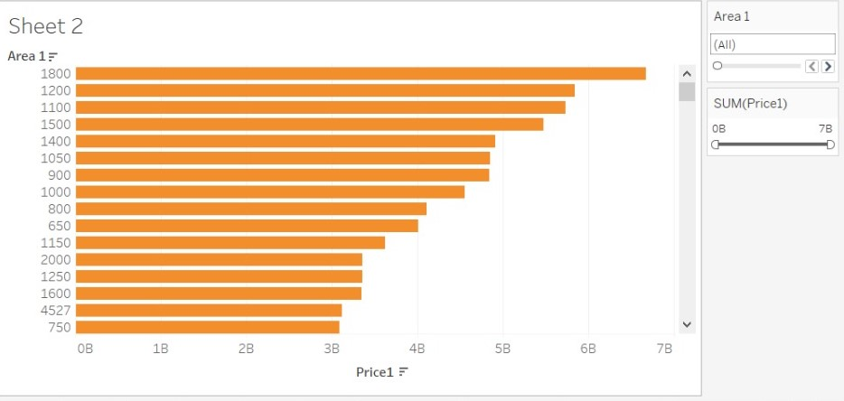

Activity 1.3: Houses prices based on rainwater harvest pits

- Drag the Location in columns
- Drag the SUM (Price) and SUM (Rainwater Harvesting) in rows with dual axis

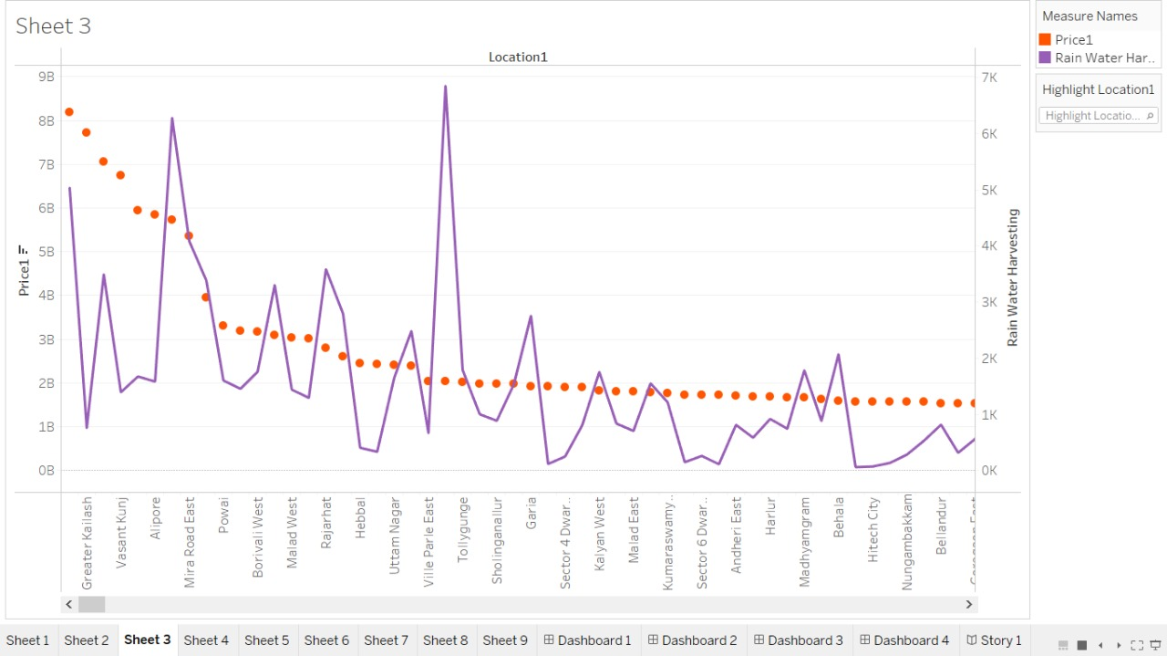

Activity 1.4: Vastu-complaints based on location

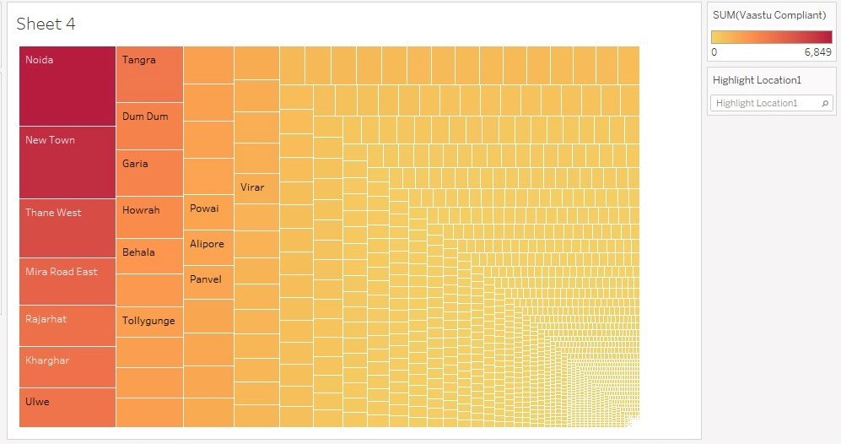

Activity 1.5: House price based on Number of Bedrooms

- Drag the Location in columns
- Drag the SUM (Price) in rows

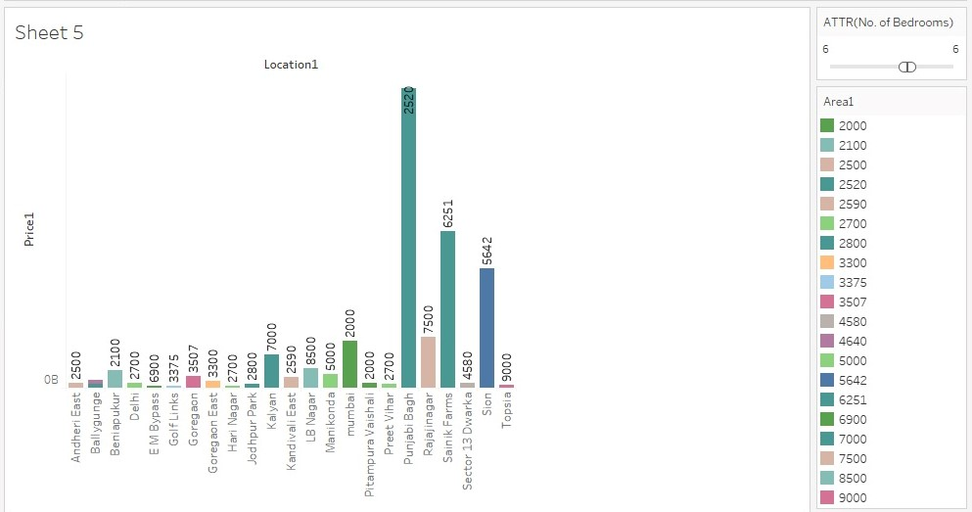

Activity 1.6: Hospitals and schools near the Houses

- Drag the SUM (Hospital) and SUM (School) in rows with dual axis

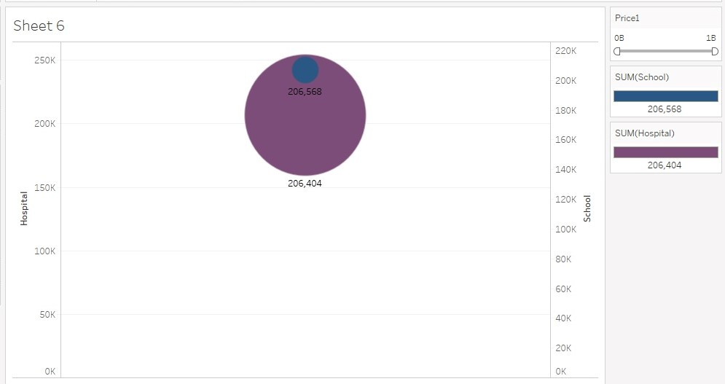
Activity 1.7: Maintains staff in houses prices

- Drag the SUM (Maintenance staff) and SUM (Price) in rows with Dual axis

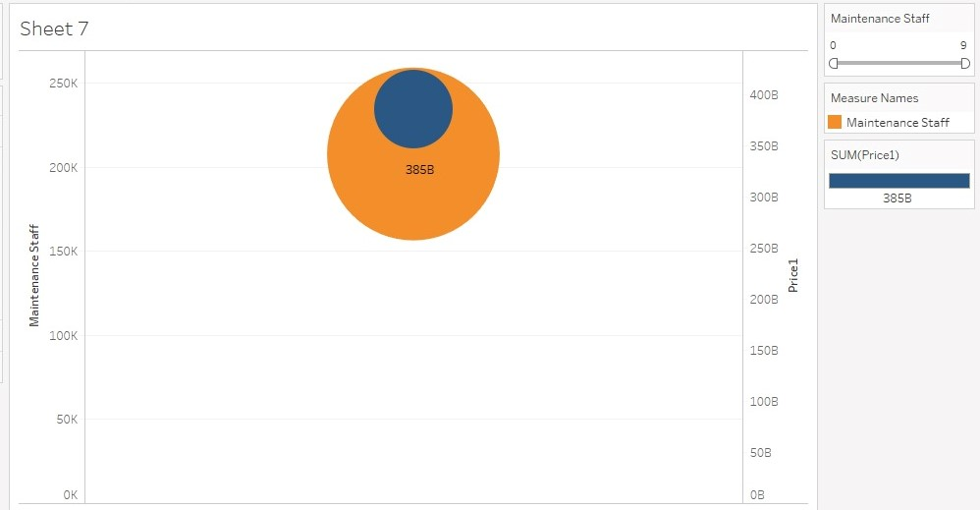

Activity 1.8: House Price and Intercom

- Drag the SUM (Price), SUM (0) and SUM (Intercom) in columns
- Drag the location in rows

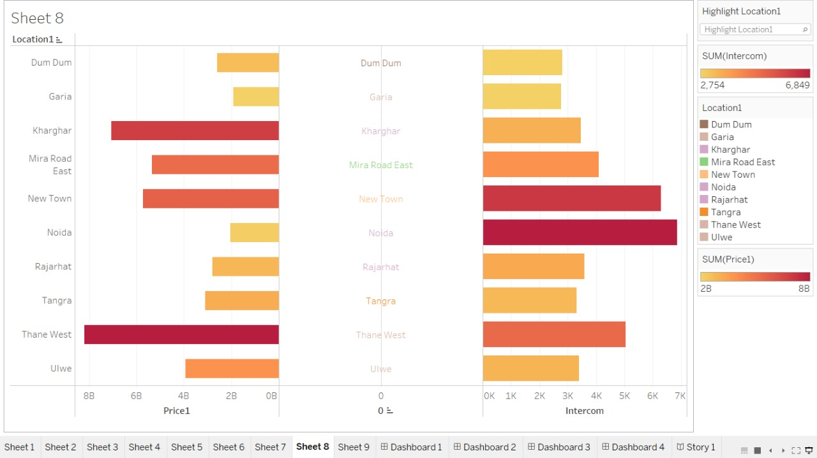

Activity 1.9: All Services based on locations

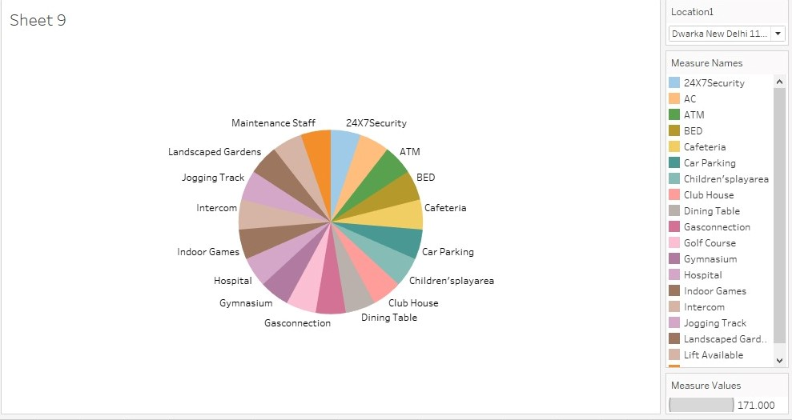

Milestone 5: Dashboard

Dash board is a GUI that displays information and data in an organized, easy-to-read format. It can be used to track key performance indicators (KPIs), monitor performance metrics, and display data in the form of charts, graphs, and tables

.
Activity 1- Responsive and Design of Dashboard

To create views on different sheets in Tableau, we can pull them into a dashboard.

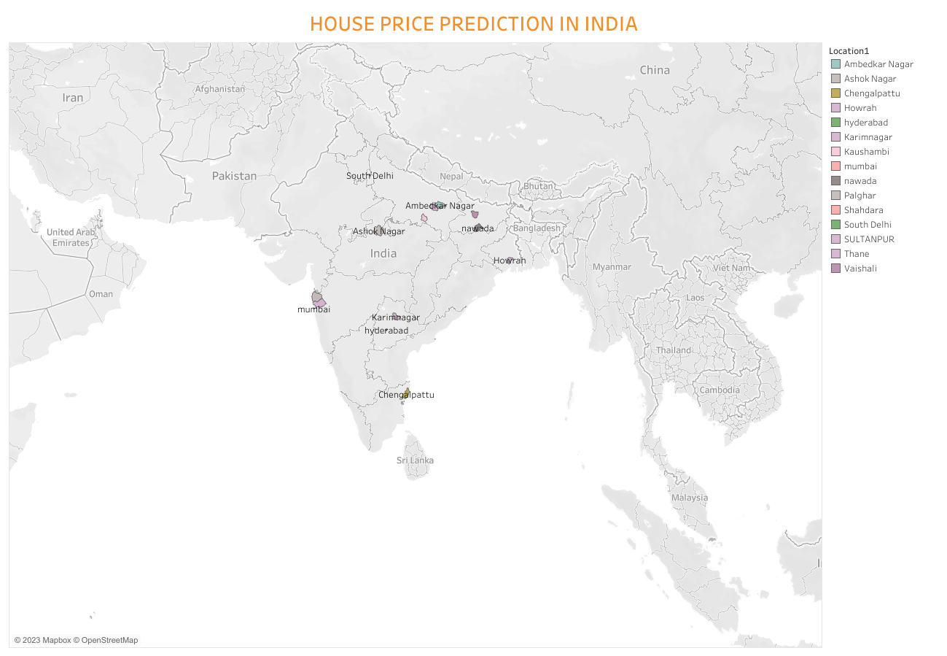

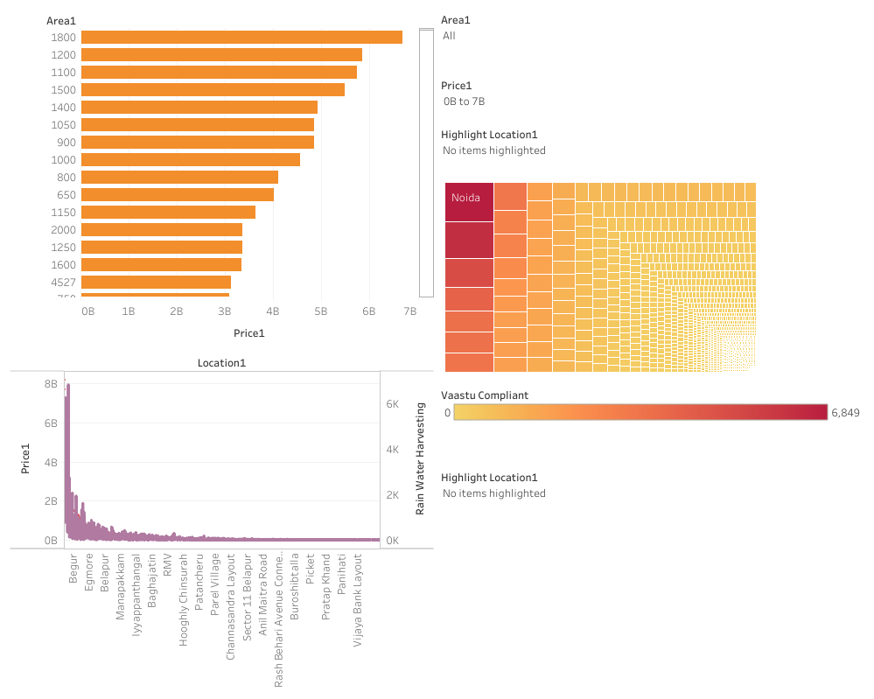

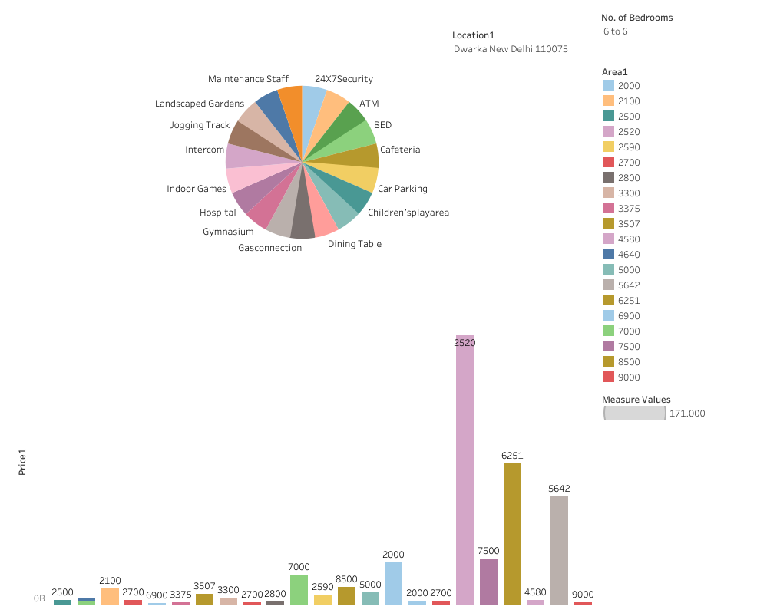

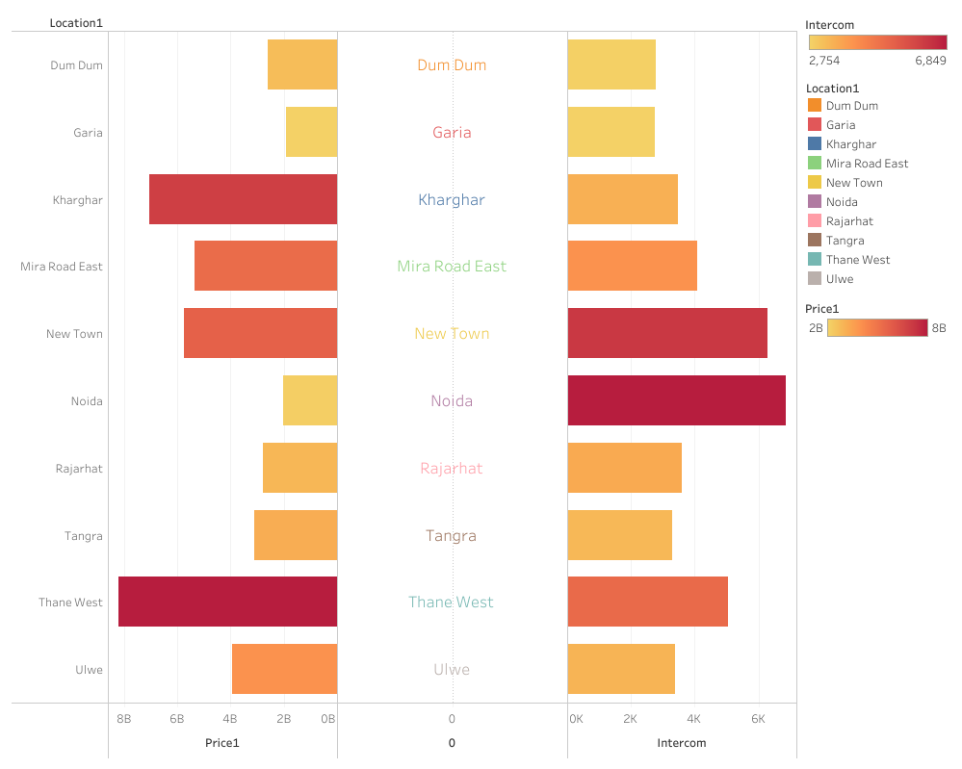

Milestone 6: Story
A data story is a way of presenting data and analysis in a narrative format, intending to make the information more engaging and easier to understand. Data stories can be told using a variety of mediums, such as reports, presentations, interactive visualizations, and videos.
Activity 1- Number of Scenes of story
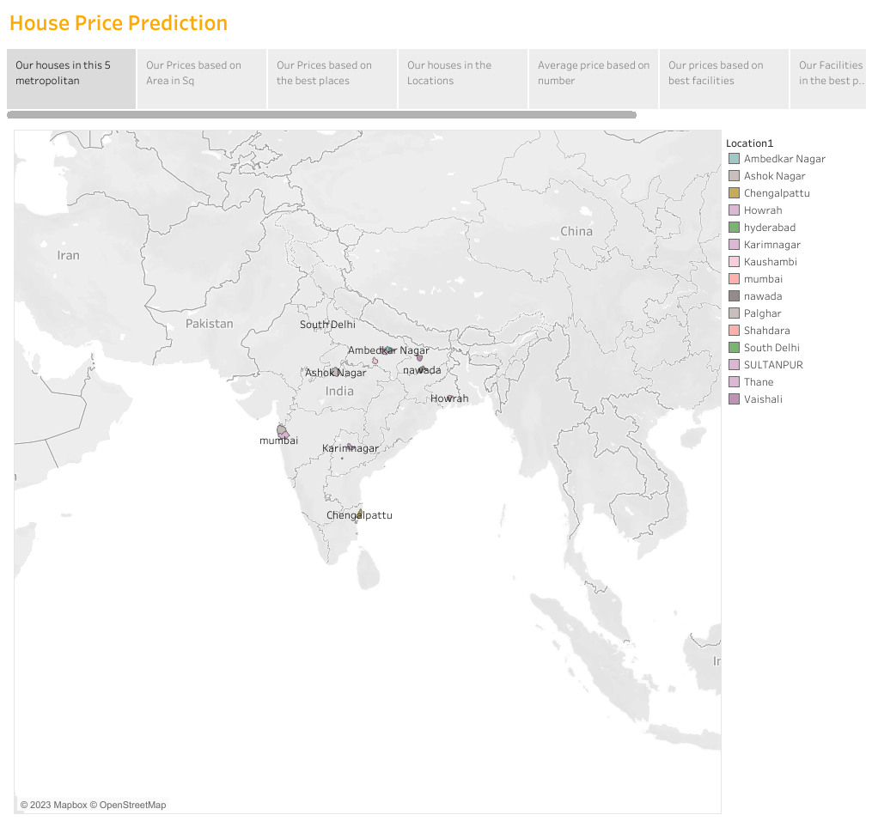

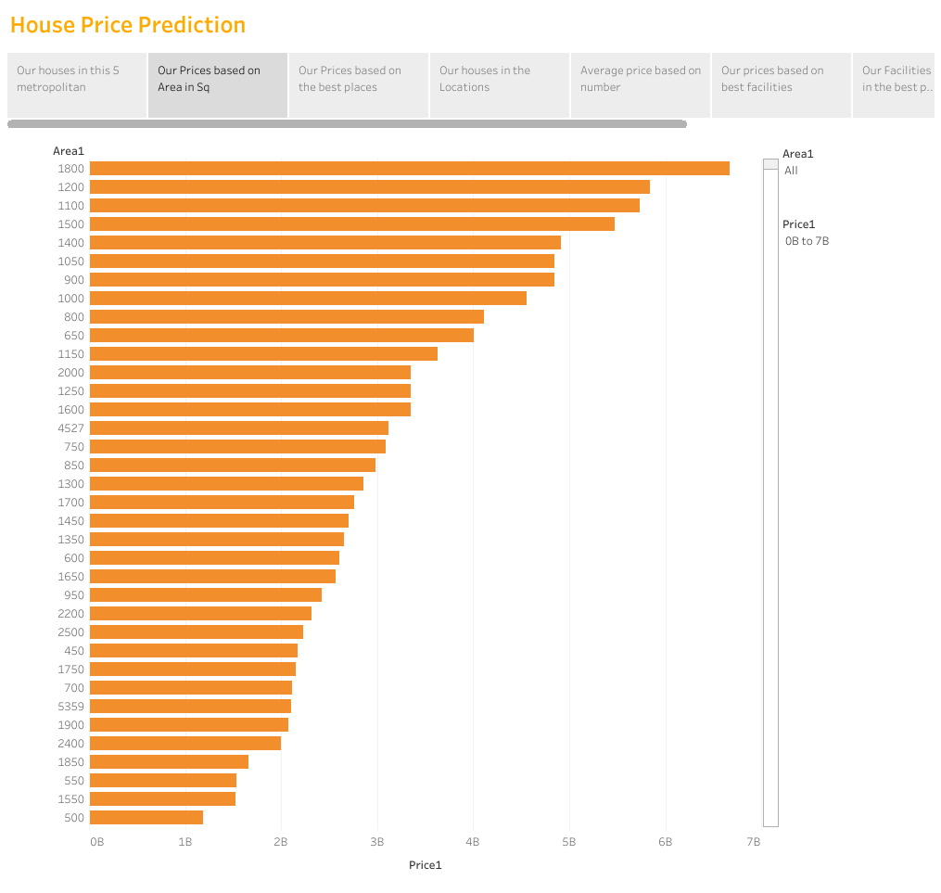
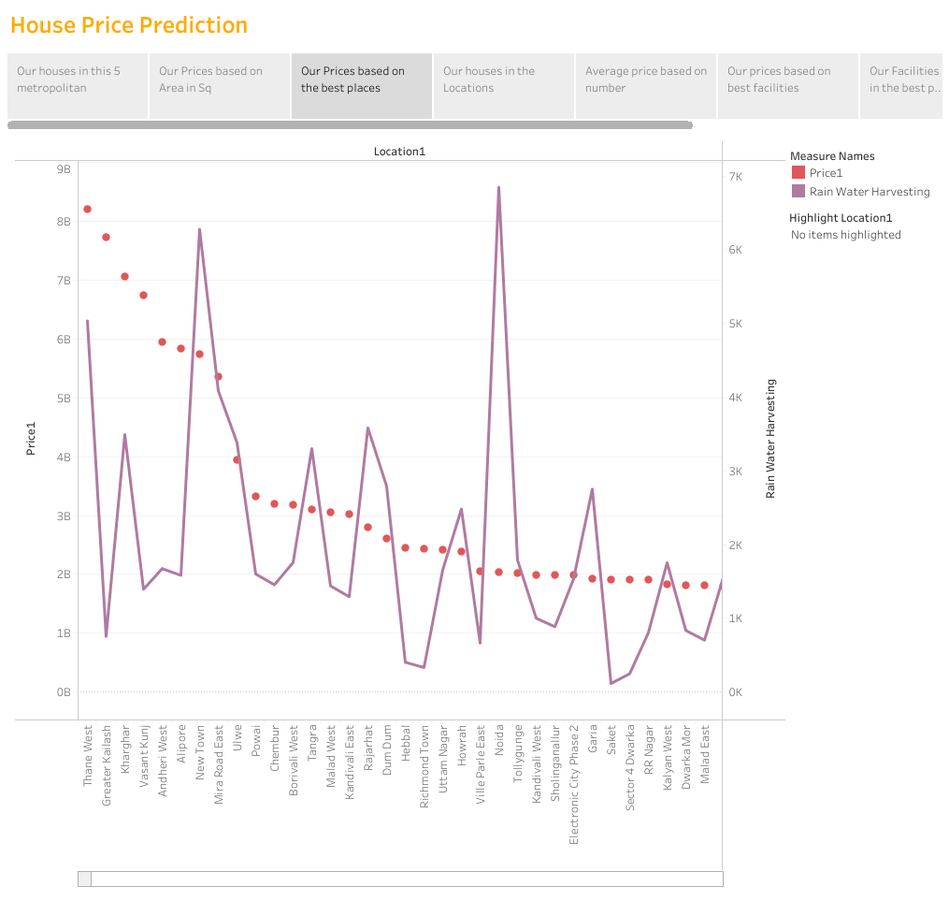

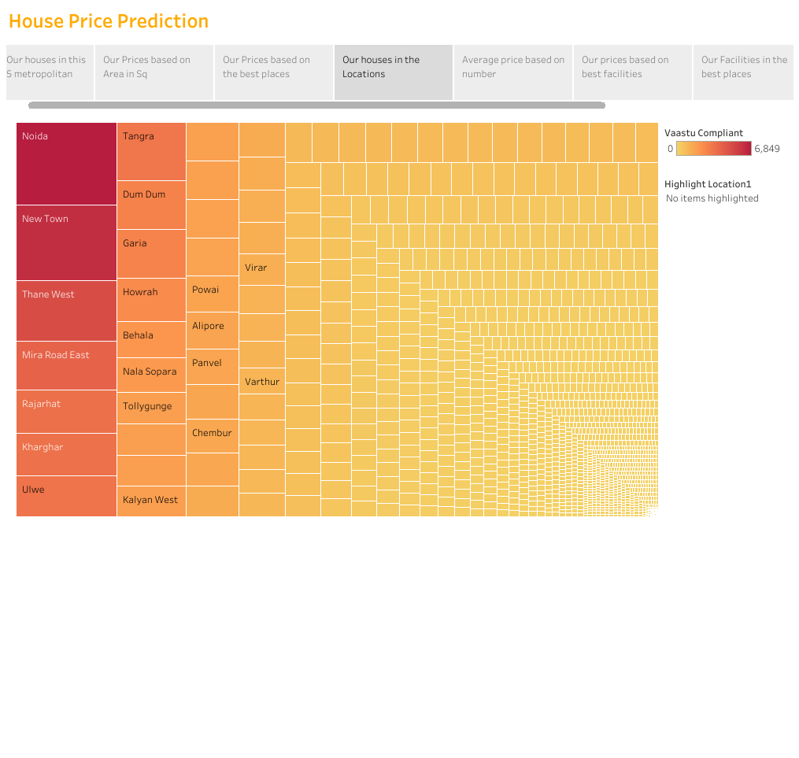
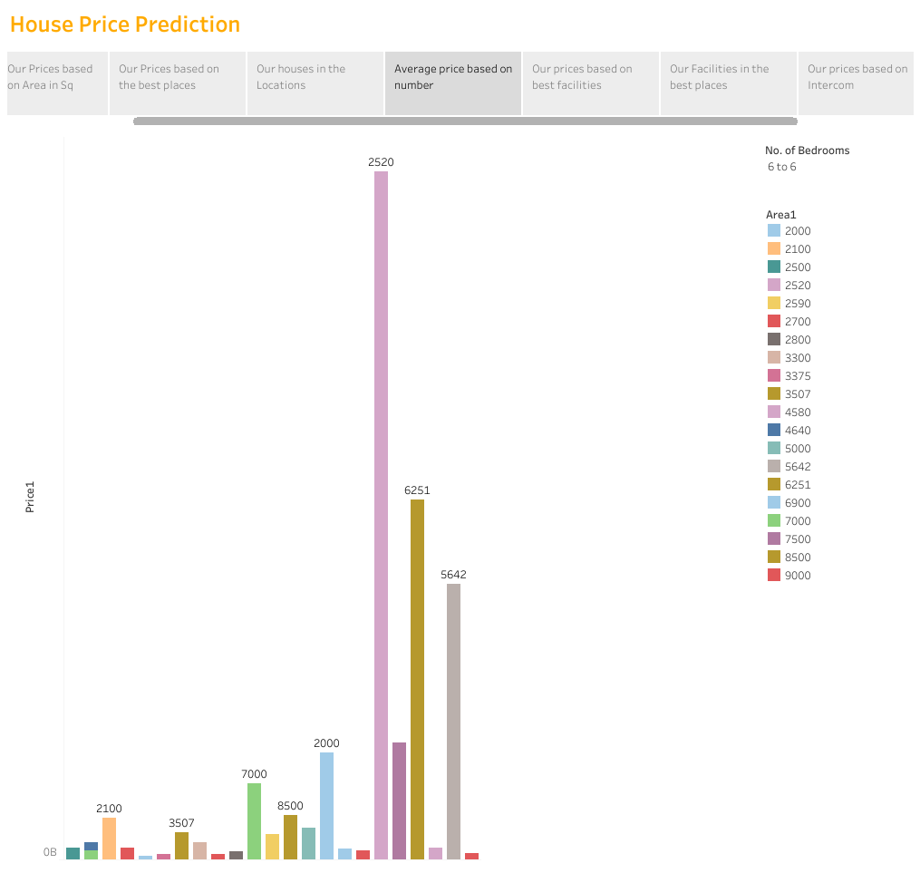
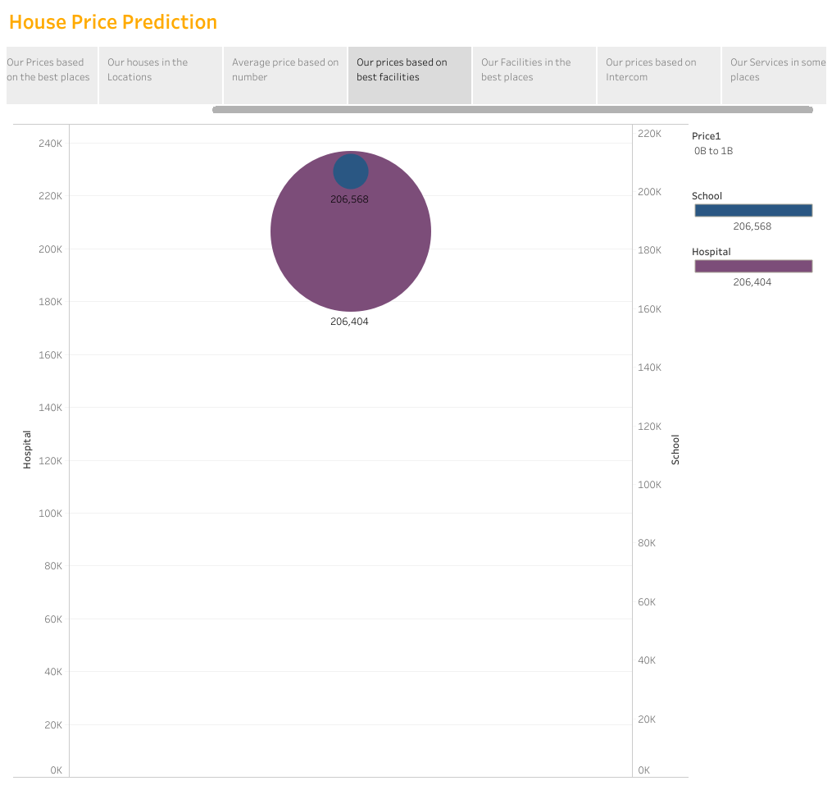
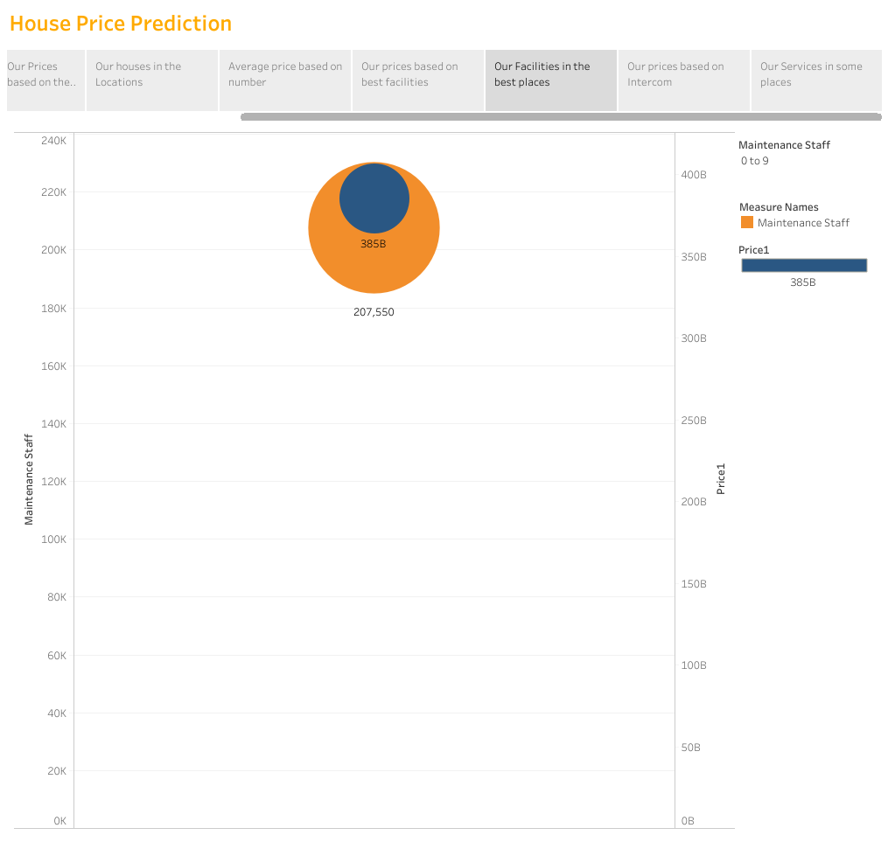
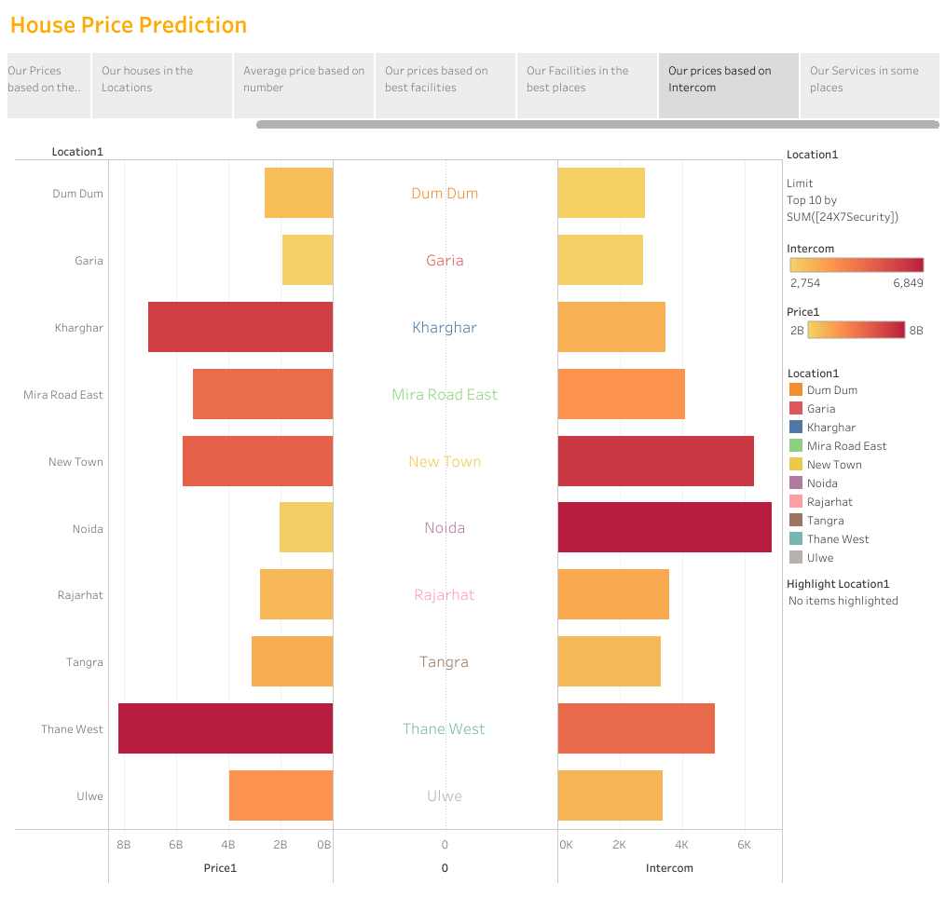
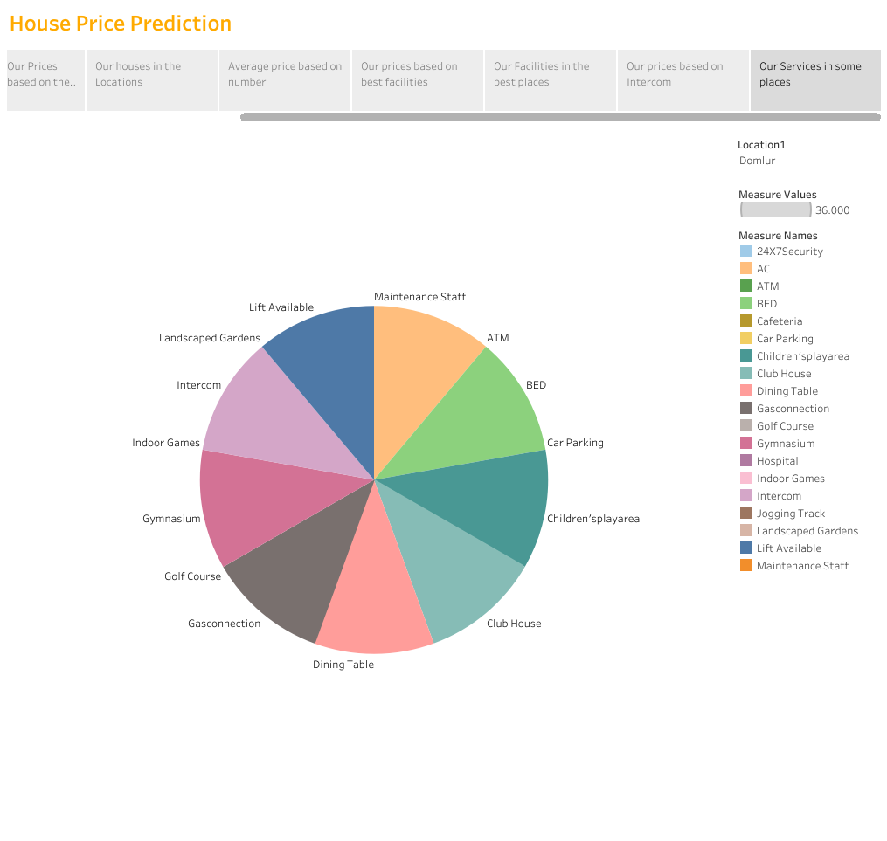

Milestone 7: Performance Testing

Activity 1: Utilization of Filters

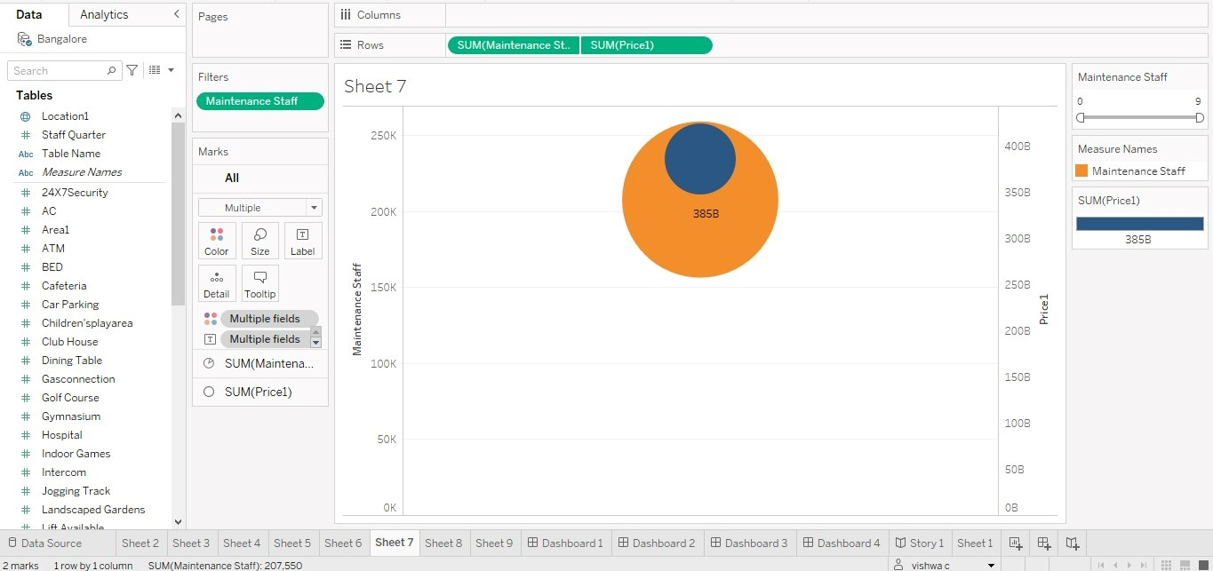
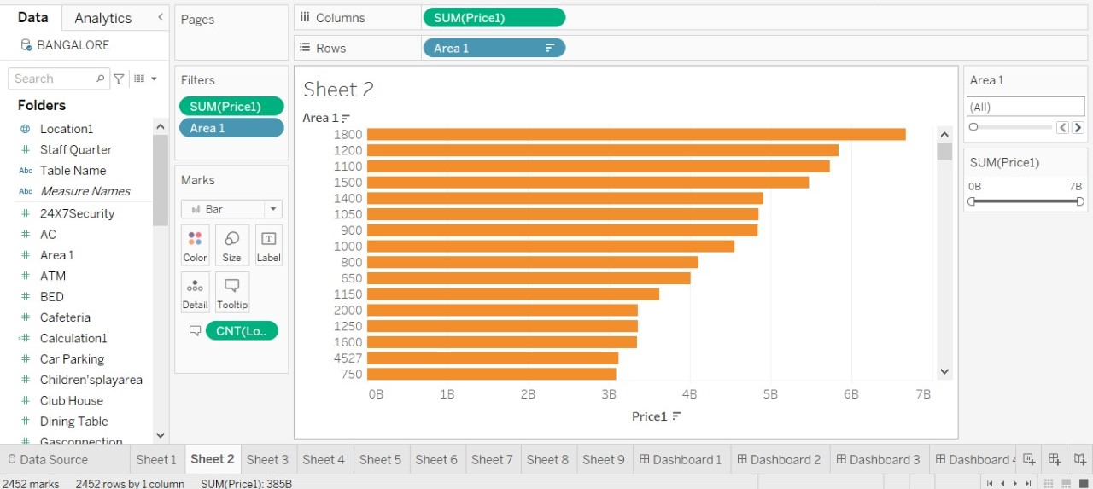

Activity 2: Number of Visualizations/ Graphs

1. Latitude and Longitude based on Location
2. Number of houses based on area in square feet
3 .Houses price based on Rainwater Harvest pits
4. Vastu-complaints based on location
5 House price based on Number of Bedrooms
6. Hospitals and Schools near the Houses
7. Maintains staff in houses prices
8. House Price and Intercom
9. All services based on locations

Milestone 8: Publishing

Publishing helps us to track and monitor key performance and to communicate results and progress. Help a publisher stay informed, make better decisions, and communicate their performance to others.

Publishing dashboard and reports to tableau public

Step 1: Go to data Source and Select Extract so that. Hyper extension files are created and save it at your desktop.
(Please wait for pop up of file to save)
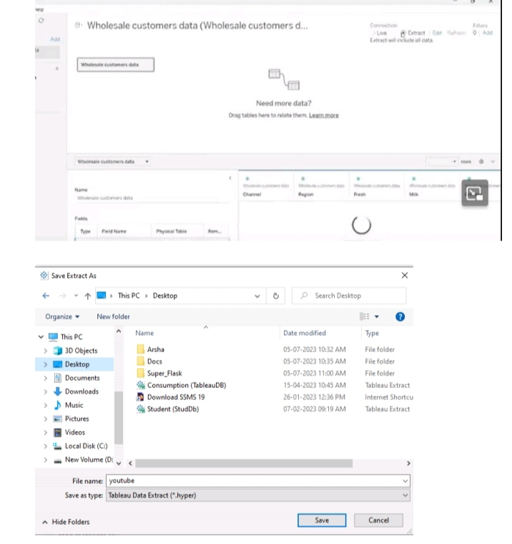

Step 2: Go to Dashboard/ Story, click on the share button on the top ribbon
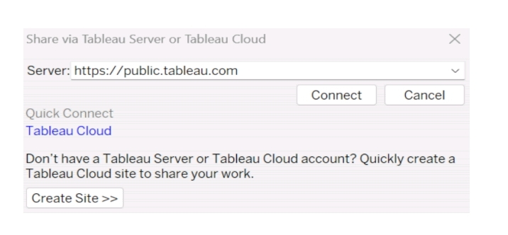
Give the server address of your tableau public account and click on connect.
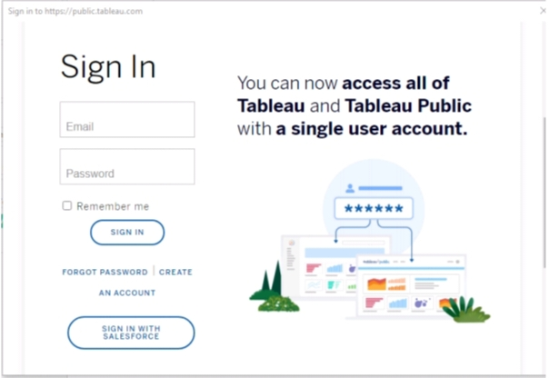

Sign in to your Tableau Public account or create a new account if you don’t have one. You can visit the Tableau Public website (public.tableau.com) and click on the “Sign In” or “Join” button.
In the “Tableau Public Sign In” window, enter your Tableau Public account credentials and click “ Sign In”.
Next, you’ll need to provide a title and description for your workbook. Fill in the appropriate details in the provided field of workbook Title

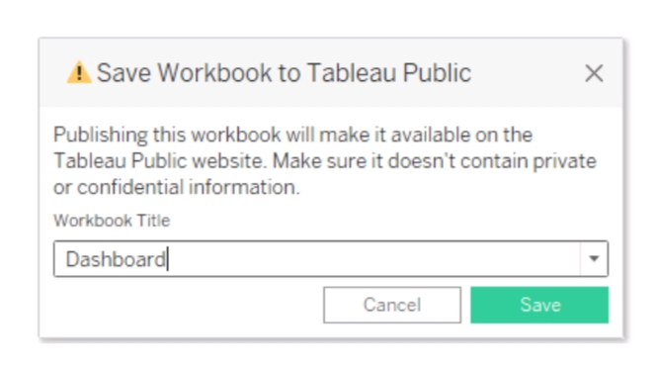
Click on the “Save” button to start the publishing process, Tableau Desktop will upload your workbook to Tableau Public.
Once the upload is complete, a browser window will automatically open, displaying your published workbook on Tableau Public. Review the workbook to ensure that everything appears as expected.
So in Similar way we can also publish Story to tableau public.
Once you login into your tableau public using the credentials, the particular visualization will be published into the tableau public.

Note: While publishing the visualization to the public, the respective sheet will get published when you click on the share option.

Milestone 9: Project Demonstration & Documentation
Below mentioned deliverables to be submitted along with other deliverables

Activity 1: Record explanation Video for the project’s end-to-end solution.

Demo Video Link:
https://drive.google.com/file/d/1xcmw3B9dA_3CYt9pa5UuSJqCHIv3OdrU/view?usp=share_link

Activity 2: Project Documentation-Step by step project development procedure.

Documentation Link:
https://docs.google.com/document/d/1m2nZMNTqrBHjlySz6WsdRDBGnfPqKPde/edit?usp=share_link&ouid=114406239982397027605&rtpof=true&sd=true

Project Link:
Team Leader:
Dashboard Links:
https://public.tableau.com/app/profile/renuga.devi.p/viz/HOUSEPRICEPREDICTIONININDIA/Dashboard1?publish=yes
https://public.tableau.com/app/profile/renuga.devi.p/viz/HOUSEPRICEPREDICTIONININDIA/Dashboard2?publish=yes
https://public.tableau.com/app/profile/renuga.devi.p/viz/HOUSEPRICEPREDICTIONININDIA/Dashboard3?publish=yes
https://public.tableau.com/app/profile/renuga.devi.p/viz/HOUSEPRICEPREDICTIONININDIA/Dashboard4?publish=yes
Story Link:
https://public.tableau.com/app/profile/renuga.devi.p/viz/HOUSEPRICEPREDICTIONININDIA/Story1?publish=yes
Team Member 1:
Dashboard Links:
https://public.tableau.com/app/profile/vishwa.c8062/viz/HOUSEPRICEPRODICTIONININDIA/Dashboard1?publish
https://public.tableau.com/app/profile/vishwa.c8062/viz/HOUSEPRICEPRODICTIONININDIA/Dashboard2?publish=yes
https://public.tableau.com/app/profile/vishwa.c8062/viz/HOUSEPRICEPRODICTIONININDIA/Dashboard3?publish=yes
https://public.tableau.com/app/profile/vishwa.c8062/viz/HOUSEPRICEPRODICTIONININDIA/Dashboard4?publish=yes
Story Link:
https://public.tableau.com/app/profile/vishwa.c8062/viz/HOUSEPRICEPRODICTIONININDIA/Story1?publish=yes

Team Member 2:
Dashboard Links:
https://public.tableau.com/app/profile/ramya.s6477/viz/HOUSEPRICEPREDICTIONININDIA_16958242774650/Dashboard1?publish=yes
https://public.tableau.com/app/profile/ramya.s6477/viz/HOUSEPRICEPREDICTIONININDIA_16958242774650/Dashboard2?publish=yes
https://public.tableau.com/app/profile/ramya.s6477/viz/HOUSEPRICEPREDICTIONININDIA_16958242774650/Dashboard3?publish=yes
https://public.tableau.com/app/profile/ramya.s6477/viz/HOUSEPRICEPREDICTIONININDIA_16958242774650/Dashboard4?publish=yes
Story Links:
https://public.tableau.com/app/profile/ramya.s6477/viz/HOUSEPRICEPREDICTIONININDIA_16958242774650/Story1?publish=yes
Team Member 3:
Dashboard Links:
https://public.tableau.com/app/profile/sri.nithi2144/viz/HousepricePredictionInIndia/Dashboard1?publish=yes
https://public.tableau.com/app/profile/sri.nithi2144/viz/HousepricePredictionInIndia/Dashboard2?publish=yes
https://public.tableau.com/app/profile/sri.nithi2144/viz/HousepricePredictionInIndia/Dashboard3?publish=yes
https://public.tableau.com/app/profile/sri.nithi2144/viz/HousepricePredictionInIndia/Dashboard4?publish=yes
Story Links:
https://public.tableau.com/app/profile/sri.nithi2144/viz/HousepricePredictionInIndia/Story1?publish=yes

Team Member 4:
Dashboard Links:
https://public.tableau.com/views/Book1_16964078920420/Dashboard1?:language=en-US&publish=yes&:display_count=n&:origin=viz_share_link
https://public.tableau.com/views/Book1_16964078920420/Dashboard2?:language=en-US&publish=yes&:display_count=n&:origin=viz_share_link
https://public.tableau.com/views/Book1_16964078920420/Dashboard3?:language=en-US&publish=yes&:display_count=n&:origin=viz_share_link
https://public.tableau.com/views/Book1_16964078920420/Dashboard4?:language=en-US&publish=yes&:display_count=n&:origin=viz_share_link
Story Links:
https://public.tableau.com/views/Book1_16964078920420/Story1?:language=en-US&publish=yes&:display_count=n&:origin=viz_share_link

5. ADVANTAGES & DISADVANTAGES
Analyzing Housing Prices in Metropolitan Areas of India can have both Advantages and Disadvantages. Some of these are:

ADVANTAGES:
- House Price Prediction can help the developer determine the selling price of a house and help the customer to arrange the right time to purchase a house.
- There are three factors that influence the price of a house which include physical conditions, concept and location.
- Increasing prices can improve your profitability even though your sales volume may drop. You can use the price change as an opportunity to the benefits you offer.

DISADVANTAGES:
- It does not predict future prices of the house mentioned by the customer. Due to this, the risk in investment in an apartment or an area increases considerably. To minimize this error, customers tend to hire an agent which again increases the cost of the process.
- Real estate investments tend to have high transactional costs, especially in legal and brokerage fees. The process of acquiring a new property is also very long and tedious with lots of legal formalities.
- No equity growth or store of value. Lifestyle limitations, Decorating limitations, less predictable housing expense, Move in costs, Insurance costs, large down payment.

6. APPLICATIONS

Analyzing Housing Prices in Metropolitan Areas of India can help the developer determine the selling price of a house and can help the customer to arrange the right time to purchase a house. Some of these applications include:

1. Collect the Down Payment: The first requirement to buy a home is a down payment. This is the money you pay upfront to offset the amount you need to borrow. To get the best available, you should have 20% to put down. The money is distributed through the states, and each has its own rules.

2. Choose Lender: It’s important to shop around for a lender. Every bank sets its own loan rates, and a fractional difference adds up to a lot of bucks over 15 or 30 years. You can start off by checking with your own bank. It might offer you a competitive rate because you already do business with them.

3. Check Your Credit Score: Your score indicates to lenders how likely you are to repay the money you borrow. The higher your credit score, the better the interest rate you will be offered. If you have a bad score or, even worse, no credit history at all, it will be very difficult to equality at all.

7. CONCLUSION

In conclusion, Analyzing Housing Prices in Metropolitan Areas of India analyzed the data mining techniques used to predict house prices. The accurate prediction model would allow investors or house buyers to determine the realistic price of a house as well as the house developers to decide the affordable house price. The price of a house is dependent on wide factors which are its features such as number of bedrooms, area of construction, locality of the house and many external factors such as air pollution and crime rate. These all factors make the prediction of price of the house more complex.

- House price indices can provide significant inputs to central banks in attaining its objectives of price stability, financial stability and growth. Construction of a house price index poses challenges due to heterogeneity of houses, renovation as well as depreciation problems and infrequency of sales.
- Thus, we studied and applied the concept of Linear Regression in real time implementation so as to ease the life of human. Determining the price of property without complete knowledge about the surrounding is quite riskier for both customer and the seller.
- Data provide us with the complete data about the surrounding in the form of dataset.

8. FUTURE SCOPE

The future scope of Analyzing Housing Prices in Metropolitan Areas of India can help the developer determine the selling price of a house and can help the customer to arrange the right time to purchase a house. Some of these include:

- Our model had a low score, but there is still room for improvement. In real world scenario, we can use such a model to predict house prices. This model should check for new data, once in a month, and incorporate them to expand the dataset and procedure better results.
- We can try out other dimensionality reduction techniques like feature selection and recursive feature elimination in the initial stages.
- By addressing these requirements, the prediction model provides reliable insights, empowering stakeholders to make informed decisions in the fast-paced real estate market.

